Ideation Phase

Define the Problem Statements

|  |  |
| --- | --- |
| Date | 19 september 2022 |
| Team ID | PNT2022TMID25439 |
| Project Title | Emerging Methods for Early Detection of Forest Fires |
| Maximum Mark | 2 marks |

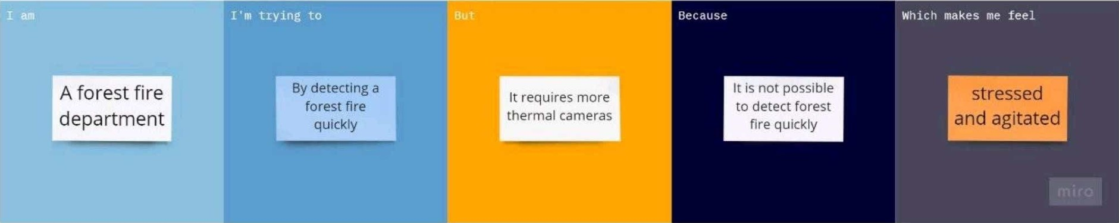

|  |  |
| --- | --- |
| Problem statement(ps): | A Large destructive fire that spread over a forest or area of woodland is a Forest fire that causes loss of humungous amount of Property, Wildlife, Ecosystem and Economy. The project is focused on creating a permanent solution for this problem. It consists of an integrated IOT based system to detect, monitor and solve the issue without any manual involvement. The system consists of regular monitoring of the forest area with the help of cloud computing and analysis of the root cause of the fire. The system uses the latest Microcontroller, Wi-Fi communication and precision sensors such that there is no error in this part. The system also provides a quick response system so the fire can be controlled at the earliest stage. |
| IAM | A Forest fire department |
| I'm trying to | Frequently monitor fire and make sure to prevent them from getting destroyed .Analyze data from various thermal camera's |
| But | Requires a lot of thermal cameras for monitoring |
| Because | It's really hard to cover large boundaries and monitor them 24 hours a day |
| Which makes me feel | Stressed and agitated about the forests are burning fastly. |